PRO. SUM OF INTEGERS

AIM: To implement a prolog program to suggest Dieting System Based on Disease.

OBJECTIVES:
- To develop a simple Prolog-based diet recommendation system that suggests general food choices according to a selected disease or health condition
ALGORITHM:
- Start the Prolog program.
- Define diseases/conditions such as diabetes, hypertension, anemia, and obesity.
- Define recommended foods for each condition.
- Define foods that should generally be limited.
- Ask the user to enter a disease.
- Search the database for matching recommendations.
- Display recommended and restricted foods.
- Stop.

SYSTEM-ARCHITECTURE:
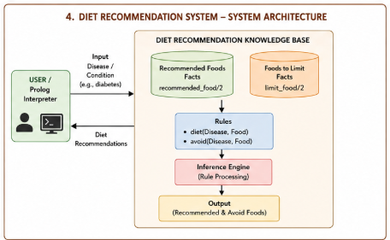

PROGRAM:
% DIET RECOMMENDATION SYSTEM

% Recommended foods

recommended_food(diabetes, vegetables).
recommended_food(diabetes, whole_grains).
recommended_food(diabetes, beans).
recommended_food(diabetes, nuts).

recommended_food(hypertension, vegetables).
recommended_food(hypertension, fruits).
recommended_food(hypertension, whole_grains).
recommended_food(hypertension, low_fat_dairy).

recommended_food(anemia, spinach).
recommended_food(anemia, beans).
recommended_food(anemia, lentils).
recommended_food(anemia, iron_fortified_foods).

recommended_food(obesity, vegetables).
recommended_food(obesity, fruits).
recommended_food(obesity, whole_grains).
recommended_food(obesity, lean_protein).

% Foods to limit

limit_food(diabetes, sugary_drinks).
limit_food(diabetes, sweets).

limit_food(hypertension, salty_foods).
limit_food(hypertension, processed_foods).

limit_food(anemia, tea_with_meals).
limit_food(anemia, coffee_with_meals).

limit_food(obesity, fried_foods).
limit_food(obesity, sugary_foods).

% Diet recommendation rule

diet(Disease, Food) :-
recommended_food(Disease, Food).

% Food restriction rule

avoid(Disease, Food) :-
limit_food(Disease, Food).

OUTPUT:
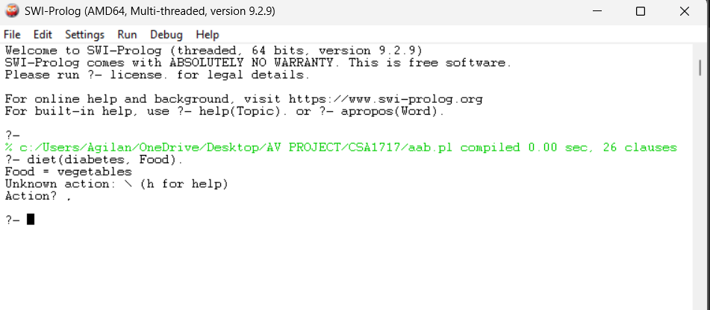

RESULT: Thus the Dieting System Based on Disease is implemented successfully using Prolog program.

